**Documentation of Eclipse, The automation system.**

~Pratic Chakraborty

Creator.

The Eclipse is a web-based home automation system. Can be accessed only if connected to the home router. The system measures and shows temperature and humidity on an LCD display constantly, irrespective of the selected mode. Talking of modes, the device can run in two modes. Web mode and physical mode. In web mode physical controls are turned off and automation services can be activated. But in physical mode the system can operate without a router or wi-fi.

***Technical Specifications:-***

1. The system uses a raspberry pi 4 model b with 4 GB ram.
2. As a slave device a RP2040 microcontroller is used.
3. As a temperature recording and display driver an ATmega328 / 328p is used.
4. To achieve isolation between input and output voltage states LM324 opamp ICs are used.
5. For switching purpose IRF44nZ Mosfet is used and BC547 BJT transistor is used.
6. 10k ohm resistor is used as pull down.
7. 5V relays / Triac used for AC switching.
8. DHT 11 sensor used as Temperature and humidity sensor, with +- 1 deg.C accuracy.
9. NI-CD LDR is used to detect light.
10. 1602 LCD display.

***Software:-***

Bootstrap 5.1 in frontend and Python Flask is used at backend. See the codes for more insights.

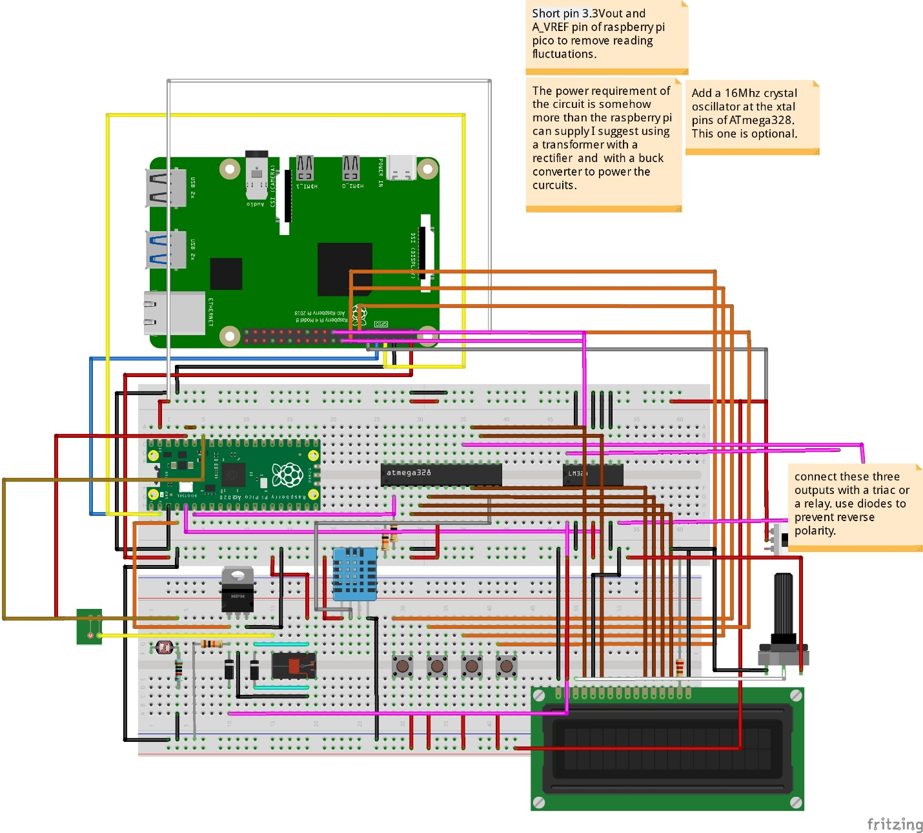

In the schematic diagram we can se the 3.3V_out and A_VREF of the RP2040(Raspberry pi pico) are shorted.

Note:- Short pin 3.3V_OUT and A_VREF in order to reduce ADC reading fluctuations.

The three open pink wires are to connect the fan controlling relay/Triac. Diodes should be used for each wire in forward bias to prevent short circuits.

The RP2040 might not boot at the first time when powerd up. As a solution Board pin 21 of raspberry pi is connected with a BJT transistor to pulse the VSYS pin of RP2040. And that should turn it on.

Board pin 22 is used to reset the ATmega 328/328p on first boot. Connect raspberry pi’s board pin 22 to the reset pin to use this function.

The switch on the side is used to switch between manual and Web modes.

*Note:- In this project a raspberry pi 4 is used but in contrast a raspberry pi zero can also be used to reduce space requirements and power consumption.*

After installing the os or receiving the preinstalled memory card. Remove it and put it in your computer. In the “BOOT” partition add a empty file called “SSH” (Without any extension) and “wpa_supplicant.conf” with the following code in it:-

country=us

update_config=1

ctrl_interface=/var/run/wpa_supplicant

network={

scan_ssid=1

ssid="Your SSID"

psk="your Password"

}

Replace the SSID and Password field with appropriate data and save the file. Remove the SD card and put it back in the raspberry pi. The PI will run and connect to the wifi automatically.